**Which factors impact childbirth weight?**

A new child's gender, name, time of birth, and birth weight are nice information for a birth announcement, but birth weight is especially important for an obstetrician.

A large size at delivery has long been associated with an increased risk of injuries to a newborn and its mom. So the better a doctor can predict birth weight, the easier the delivery may be. Also, it is very important to know the impact of life-style habits, physical condition & diseases of mother, which can impact child's birth weight.

The weight of the baby depends on various factors and can be calculated based on below mentioned factors. Following features are used:

1. Difference in weight of smokers and non-smokers
2. Difference on weight based on number of prenatal visits
3. Difference in weight based on Gestational Hypertension
4. Difference in weight based on previous pre-term birth
5. Effect of Hepatitis B & C
6. Effect of taking steroids
7. Impact of mother’s age
8. Interval since last pregnancy

**Why it's important to analyze factors impacting childbirth weight?**

It’s well known that APGAR score (which is a direct measure of baby's vitals just after birth) is high for higher weighted babies. Since baby's health directly correlated with its weight, analyzing factors impacting baby's weight is really important. As soon as your baby is born, a delivery nurse will set one timer for one minute and another for five minutes. When each of these time periods is up, a nurse or physician will give your baby her first "tests," called Apgars.

What Does the Apgar Test Measure?

The test measures your baby's:

1. Heart rate
2. Breathing
3. Muscle tone
4. Reflex response
5. Color

Below analysis shows that higher APGAR score is associated with higher birth weight. This really helps to draw strong positive correlation between APGAR and body weight i.e higher the body weight, higher the health-index APGAR score value.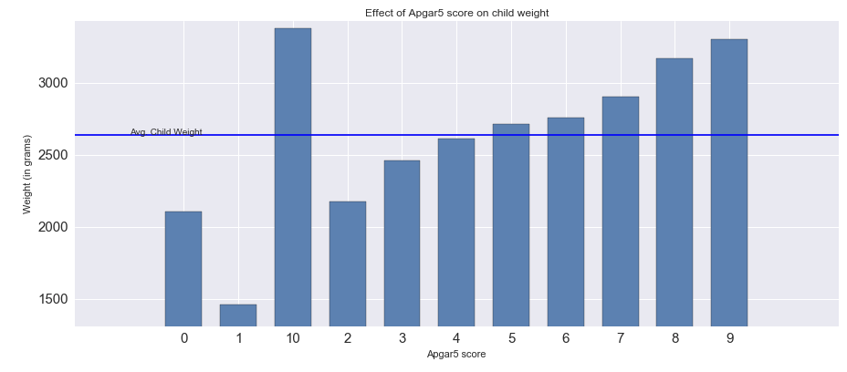

**Input Data**

The data used is available on the National Vital Statistics System which is a part of National Center for Health Statistics. It can be found on the below link:

<https://www.cdc.gov/nchs/data_access/vitalstatsonline.htm>

**Child Weight Distribution**

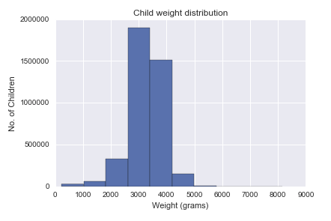

This dataset have 3.9 million records. The vital statistics for this dataset exhibit that the average childbirth weight is 3272.77 grams (7.21 lbs) with minimum of 227 grams, maximum of 8165.00 grams and standard deviation of 591.99 grams.

**What is the impact of smoking on child's weight?**

The graph below shows how women who smoke have lower average childbirth weight. This quantifies amount of average birth weight per category of number of cigarettes per day. This evidence supports a direct effect of maternal smoking on birth weight, possibly due to the hypoxic effects of carbon monoxide, rather than one mediated through eating. Efforts to prevent or reduce smoking should have greater benefits for mother and child than would efforts to increase food intake among pregnant women who smoke.

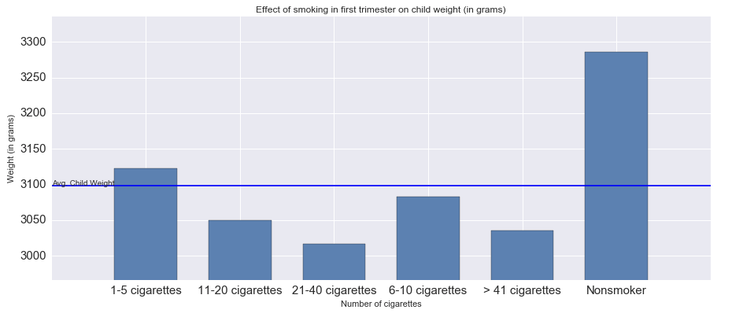

**Are pre-natal visits important? What is the ideal start period for pre-natal visits?**

No pre-natal care which results in lower child birth weight as shown below, earlier we can start higher are the chances of increased birth weight

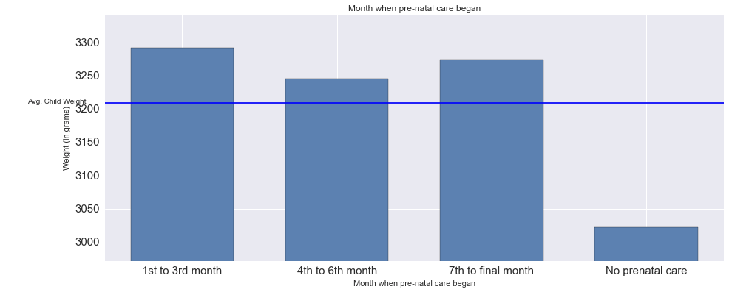

### Gestational HypertensionMacintosh HD:Users:admin:Desktop:Screen Shot 2019-08-15 at 12.03.24 AM.png

#### Above graph shows that Gestational hypertension causes lowers child body weight by approximately 8%. This high blood pressure is developed during pregnancy. It usually starts after approximately 20 weeks of pregnancy. In many cases, this may not harm baby, and it goes away within 12 weeks after childbirth. But sometimes can be severe, which may lead to low birth weight or preterm birth. Some women with gestational hypertension do go on to develop preeclampsia.

# What is effect of previous preterm birth on next child?

Previous pre-term birth will have high chances of next child having low birth weight and on average have 9.2% less mean weight.

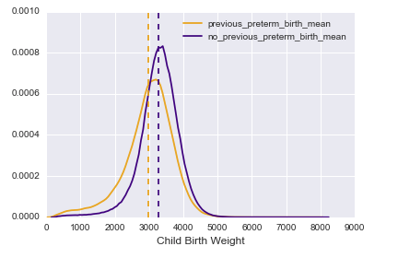

### Effect on Hepatitis on child weight (makes it important to take hepatitis vaccine)

### As shown in analysis below, Mothers with prior hepatitis B will higher chances of lower childbirth weight on average have 2.3% less mean weight. Similar results on child body weight on hepatitis C.

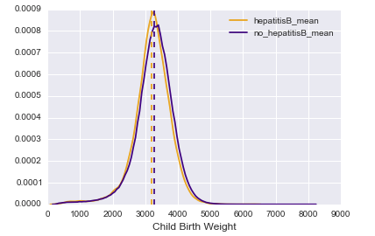

## Effect of steroids - Can I take steroids if I am planning pregnancy?

# Anabolic steroids are taken by women athletes especially in bodybuilding, weight lifting or related sports, or taken to induce ovulation. This figure shows that taking steroids significantly reduces childbirth weight by 37% on average.  Anabolic steroids cause interrupted growth and virilization in children, birth defects in the unborn, severe virilization in women [5].

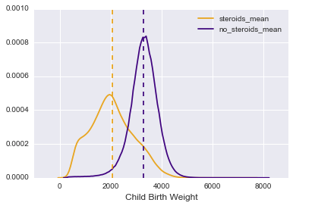

**What is the impact of mother's age child's birth weight?**

Following data shows that mothers with age between 30-34 have highest mean birth weight. Advanced maternal age at birth is considered a major risk factor for birth outcome. The associations are similar for the risk of preterm delivery. Similarly, teenage delivery and early 20s childbirth results in lower birth weight.

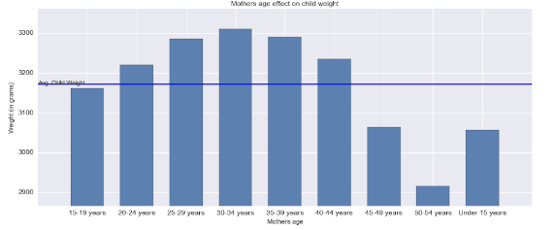

## Interval since last pregnancy

#### Below analysis shows next childbirth after 24-35 month (4.0) since last pregnancy has maximum mean weight for childbirth. Babies born to women who get pregnant very quickly after having a child or wait many years between children are at greater risk for potentially serious delivery-related complications, including premature birth and low birth w, eight. The analysis of studies involving more than 11 million women is published in tomorrow's Journal of the American Medical Association. Researchers found that infants born to women who conceived less than six months after giving birth had a 40% increased risk for being born prematurely and a 61% increased risk of low birth weight, compared with infants born to mothers who waited 18 months to two years between pregnancies.

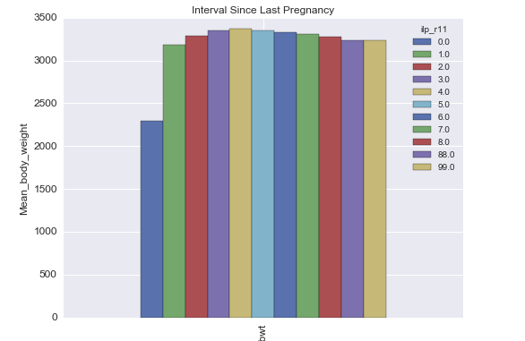

**Conclusion**:

Based on above data analysis preformed, smoking, gestational hyper tension, previous term birth, Hepatitis B & C, steriods impacts childbirth weight adversely while pre-natal visits, taking gap between pregnancy and planning pregnancy at right age helps to improve birth weight.

**Reference**:

1. <https://www.webmd.com/baby/news/20060418/pregnancy-spacing-affects-outcome#1>

2. <https://www.ncbi.nlm.nih.gov/pubmed/29206985>

3. NCHS Vital Stats Birth Data

<http://www.nber.org/data/vital-statistics-natality-data.html>

4. NCHS - Births, Birth Rates, and Fertility Rates, by Race of Mother <https://catalog.data.gov/dataset/births-birth-rates-and-fertility-rates-by-race-of-mother-united-states-1960-2013>

5. <https://www.ncbi.nlm.nih.gov/pubmed/6367501>